1

Defining Advisory Board Purpose
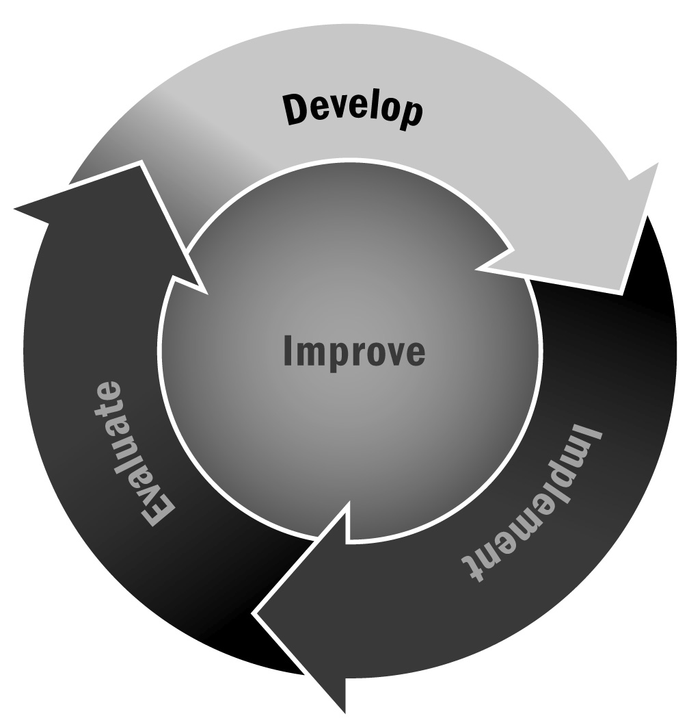
In Chapter 1, you learned that advisory boards can serve an important function—providing guidance in program design, offering advice and suggestions, and helping to form partnerships. Although a board is important, it can sometimes be difficult to decide exactly what type of board you want and what role board members should play. This tool is designed to help you answer those questions.
Directions: Answer the questions and fill in the information in this tool to help you determine what kind of advisory board you need and what role you want members to play.
- What types of tasks do you need help with? – Check any task you think you would like your advisory board to help with. Look at the types of people listed below the task who might be helpful with this task. List specific people you might include.
- Advice on program design and activity plans
Types of people: Program providers; staff/administrators from partner school(s)
Name, Title, Affiliation:
Name, Title, Affiliation:
- Help creating job descriptions and hiring procedures
Types of people: People with expertise or a background in human resources. Look to the local business community.
Name, Title, Affiliation:
Name, Title, Affiliation:
- Help creating operational policies
Types of people: Program leaders of other local programs; administrators from partner school(s)
Name, Title, Affiliation:
Name, Title, Affiliation:
- Help connecting to community
Types of people: Individuals with close ties to the community, such as a community center program director, a faith-based leader, or someone from local government
Name, Title, Affiliation:
Name, Title, Affiliation:

- Help connecting to families
Types of people: Head of PTO or other local group for parents and families; family members of participating youth
Name, Title, Affiliation:
Name, Title, Affiliation:
- Fundraising support
Types of people: Individuals from the business community; staff members from local community or family foundations; individuals with connections to potential donor population
Name, Title, Affiliation:
Name, Title, Affiliation:
- Help evaluating the program
Types of people: Faculty from local college or university; graduate students; research staff members from other organizations
Name, Title, Affiliation:
Name, Title, Affiliation:
- Help with marketing
Types of people: Marketing professionals from for-profit sector or large non-profit organization
Name, Title, Affiliation:
Name, Title, Affiliation:
- Help developing a business plan/support for accounting and bookkeeping procedures
Types of people: Accountants; CPAs from local accounting firms; business managers or CFOs from large non-profits in the community
Name, Title, Affiliation:
Name, Title, Affiliation:
- Legal advice
Types of people: Local attorneys; in-house counsel for local businesses
Name, Title, Affiliation:
Name, Title, Affiliation:

- Who are your key stakeholders?
In addition to the roles you identified above, you need to make sure your key stakeholders are represented by your board. Some of the individuals you select to fill the roles in question 1 will also be your stakeholders (e.g., a director of a community-based organization can help you build partnerships and is also a member of the community). Use the checklist below to be sure you have someone in each key group. It is okay to list someone in both questions 1 and 2.
- Staff
Name, Title, Affiliation:
Name, Title, Affiliation:
- Families
Name, Title, Affiliation:
Name, Title, Affiliation:
- Partners/community-based organizations
Name, Title, Affiliation:
Name, Title, Affiliation:
- School staff/administrators
Name, Title, Affiliation:
Name, Title, Affiliation:
- Funders
Name, Title, Affiliation:
Name, Title, Affiliation:
- Youth
Name, Title, Affiliation:
Name, Title, Affiliation:
- Local government representatives
Name, Title, Affiliation:
Name, Title, Affiliation:
- How much time do you have to dedicate to an advisory board?
- Bi-annual meetings (approximately 10 hours per year)
- Quarterly meetings (approximately 20 hours per year)
- Every other month (approximately 30 hours per year)
- 1 meeting per month (approximately 60 hours per year or 5 hours per month)
- 2 meetings per month (approximately 120 hours per year or 10 hours per month)

- Do your stakeholders have conflicting viewpoints?
- Yes
Describe. Be specific:
- No
- How active do you want your advisory board to be? (Select a number from 1 to 5, with 1 being the most involved and 5 being least involved.)
- 1 – I want my advisory board to provide feedback and guidance on specific aspects of the program. I need guidance on all of my program decisions.
- 2
- 3
- 4
- 5 – I prefer a hands-off advisory board that provides guidance and advice on big-picture decisions but does not get involved in day-to-day decision-making.
Use questions 3–5 to help you determine the structure and frequency of your advisory board meetings. For example, if you answered bi-annually or quarterly to question 3, you probably want to stick with one large advisory board that represents all of your stakeholders. On the other hand, if you indicated that you want a lot of guidance and input from your board in question 5, you might want to consider forming a subcommittee structure for your board that will allow you to maximize your membership and get a lot out of each member. If your stakeholders have conflicting viewpoints, multiple small committees might be best. If your answers to the three questions vary, you may want to go with a middle-of-the-road approach—one or two committees that meet every other month, for example.
What’s Next? This tool should have helped you to identify the structure and format for your advisory board as well as a list of potential members. Once you have completed the tool, look at your answers to develop a board structure that will work for you, and then begin to reach out to your potential members. Revisit this tool periodically and as board members change to ensure you are maintaining adequate representation of your stakeholders and that the board is serving all of your purposes.

