13

Program Schedule
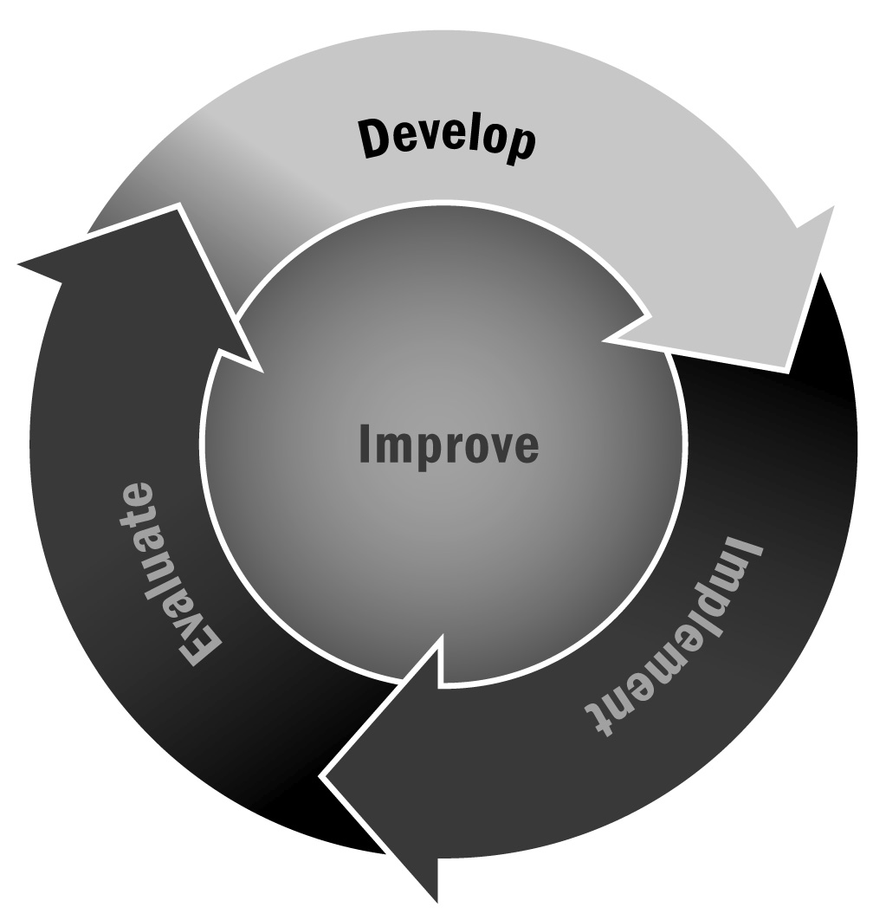
In Chapter 1, you learned that everyone benefits from having a well-defined schedule. Program staff members should know what program activities are happening and when, and young people should know where to go and for what activity. Developing and maintaining a program schedule and posting it for all to see (physically in your program as well as online, if possible) will help your program run smoothly.
Directions: Use or adapt this tool to schedule and keep track of all program offerings that occur during the school year. Be sure to include days offered, time, location, staffing, and any additional information. A sample schedule is provided below to get you started. Use the blank form on the last page for your program.

Afterschool All-Stars!
First Program Session (September–December) – 10 weeks
 | Time | Activity | Room | Staff
Monday | 3:00–3:30 | Snack (all grades) | Cafeteria | John Smith, Ann Moore, community college volunteers
 | 3:30–4:15 | Homework Center (3–5)  Homework Center (6–8) | 8  2a | Community college volunteers
 | 4:15–4:30 | Transition to enrichment activities |  | All staff members oversee
 | 4:30–5:30 | Science Alive! (3–5)  Karate (3–5)  Service Learning  Group (6–8)  Art Club (6–8) | 6  Gym  4a  4b | Audubon Society staff  Mark Jennings  Sally Lincoln  Arts for All staff
 | 5:30–6:00 | Open Rec. | Gym | John Smith, Ann Moore, community college volunteers
Tuesday | 3:00–3:30 | Snack (all grades) | Cafeteria | John Smith, Ann Moore, community college volunteers
 | 3:30–4:30 | Yoga (3–5)  Math Club (3–5)  Step Dancing  Robotics | Gym  2b  Auditorium  6 | Jennifer Sloan  Sarah Perry  DJ dance staff  Jeff Fisher
 | 4:30–4:45 | Transition to Homework Centers |  | All staff members oversee
 | 4:45–5:30 | Homework Center (3–5)  Homework Center (6–8) | 8  2a | Community college volunteers
 | 5:30–6:00 | Open Rec. | Gym | John Smith, Ann Moore, community college volunteers
Wednesday | 3:00–3:30 | Snack (all grades) | Cafeteria | John Smith, Ann Moore, community college volunteers
 | 3:30–4:15 | Homework Center (3–5)  Homework Center (6–8) | 8  2a | Community college volunteers
 | 4:15–4:30 | Transition to enrichment activities |  | All staff members oversee
 | 4:30–5:30 | Science Alive! (3–5)  Karate (3–5)  Service Learning  Group (6–8)  Art Club (6–8) | 6  Gym  4a  4b | Audubon Society staff  Mark Jennings  Sally Lincoln  Arts for All staff
 | 5:30–6:00 | Open Rec. | Gym | John Smith, Ann Moore, community college volunteers
Thursday | 3:00–3:30 | Snack (all grades) | Cafeteria | John Smith, Ann Moore, community college volunteers
 | 3:30–4:30 | Yoga (3–5)  Math Club (3–5)  Step Dancing  Robotics | Gym  2b  Auditorium  6 | Jennifer Sloan  Sarah Perry  DJ dance staff  Jeff Fisher
 | 4:30–4:45 | Transition to Homework Centers |  | All staff members oversee
 | 4:45–5:30 | Homework Center (3–5)  Homework Center (6–8) | 8  2a | Community college volunteers
 | 5:30–6:00 | Open Rec. | Gym | John Smith, Ann Moore, community college volunteers
Friday | Program Closed – Staff Planning

[Program Name]
[Program Session (Dates) – # Weeks]
 | Time | Activity | Room | Staff
Monday
Tuesday
Wednesday
Thursday
Friday

