20

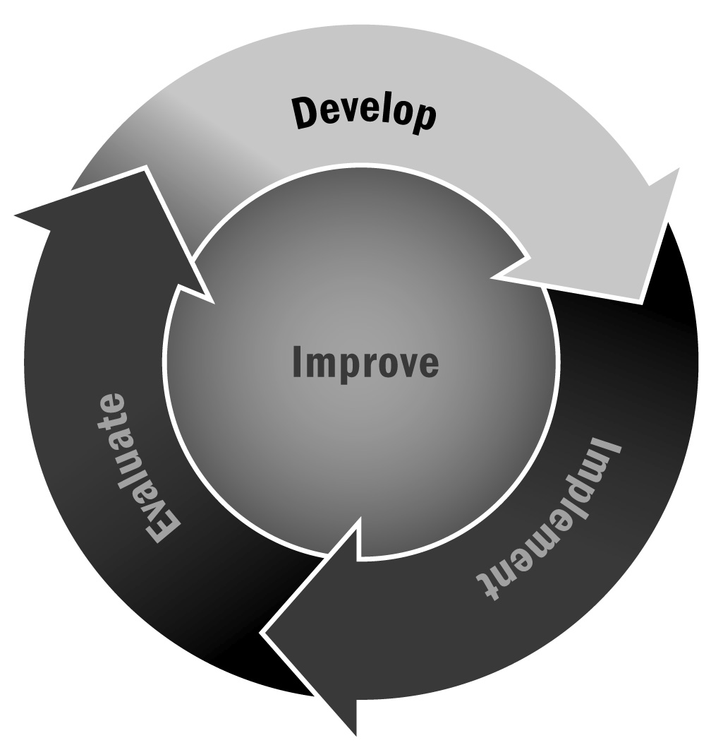
Job Description for Program Leader
In Chapter 1, you learned that you should provide program leaders a detailed job description that lists the qualifications required, the duties associated with the position, and the expectations associated with the position. A good job description will help your program attract qualified candidates and establish a positive culture of accountability.
Directions: This tool is divided into three parts. First, consider the following job description questions to identify the necessary requirements for your program. Second, read the example job description for this position. Finally, use the requirements identified in Part I and the example provided in Part II to complete the job description template in Part III.

Part I. Job Description Questions and Considerations
Job Description Section | Questions and Considerations | Requirements for Your Program
Position Title | - What is the name of the position?  - What title have others previously used?
Position Definition/ Description | - What role will this individual play within the organization? Summarize the role in one or two sentences.
Responsibilities | - What will this individual do on a day-to-day basis?  - What duties will be assigned?
Required Qualifications | - What educational background should this person have?  - How many years of work experience should this person have?  - Does it matter where the work experience was?  - Should this person have experience working with youth?  - Does this position require any certifications?  - Are there other skills that are necessary for fulfilling this role on a day-to-day basis?
Preferred Competencies and Skills | - Are there certain skills that you feel would be beneficial but that are not necessary for fulfilling this role? Should this person have other professional skills such as time management, multitasking, or decision-making?  - Are there any educational experiences you think would benefit a person in this position?  - Are there any training or professional development certifications that would enable a person to better perform in this role?
Salary | - Do you want to state the salary in this job description?  - If so, what is the salary for this position?  - Is this a salaried position or paid at an hourly rate?  - Are benefits included with this position? If so, what are they?
How to Apply | - What materials should an interested applicant submit to be considered for this position?  - How and to whom should potential applicants submit their materials for this position?
Statement of Nondiscrimination | - It is important to include a statement that describes your organization as an equal opportunity employer that does not discriminate on the basis of race, color, sex, age, disability, religion, or national origin.

Part II. Example Job Description for Program Leader
Position Title
Program Leader
Position Description
This individual will be employed full time by the program organization, the school, or the partner community-based organization (Youth Works!) to oversee the programs, activities, and collaborative processes.
Responsibilities
- Lead the afterschool and expanded learning team in an environment where they can support young people’s opportunities for positive growth and development
- Ensure that the program adheres to any organizational or grant requirements
- Hire and supervise program staff
- Assume responsibility for the building during afterschool hours
- Oversee enrollment, recruitment, and data collection
- Develop relationships and work with partner staff, families, and the local community
- Make presentations to the community, including local school boards, businesses, and community organizations
- Meet regularly with program partners (and, if school based, the principal or school leadership)
- Work closely with and provide ongoing supervision to staff members (i.e., program, sub-contractor, and volunteer staff members)
- Engage and support staff members in implementing program activities to achieve program goals
- Develop reports and oversee evaluation activities
- Develop and track budgets
- Secure donations and funding for the program
- Develop or contribute to the development of and adherence to program policies and procedures
- Analyze and apply information from periodic program evaluations
- Coordinate the planning, development, and implementation of the program
- Establish and maintain communication with members of partner agencies (for example school staff members about participants’ progress in the program)
- Implement applicable district, agency, and grant policies and regulations

- Provide oral and written reports to the organization, the agency, the public, and the local school system
- Facilitate partnerships with appropriate public and private agencies that provide supports to participants and their families
- Prepare proposals for supplemental funding
- Participate on local and state committees related to afterschool and expanded learning programs
- Maintain the records needed for program administration or monitoring
- Report to the organization director for other duties, as assigned
Required Qualifications , Competencies, and Skills
- Holds a bachelor’s degree in education, youth development, nonprofit administration, or another related field
- Must pass a criminal background check
- Has prior experience in strategic planning, program development, and operation
- Has prior experience in afterschool and expanded learning programs, either in a school- or community-based setting
- Has prior experience working with youth
- Possesses strong leadership skills
- Is able to multitask
- Is able to resolve challenging situations productively and without personalization
- Pays attention to detail
- Is able to work well under stress
- Has a valid driver’s license and personal vehicle insurance or access to reliable transportation
Preferred Qualifications, Competencies, and Skills
- Holds a master’s degree in education, youth development, or another related field
- Has previous experience in grant writing, management, and reporting
- Has previous experience in program evaluation and data use for continuous program improvement
- Has prior experience in an educational or recreational setting, in a school- or community-based organization
- Is committed to afterschool and expanded learning
- Has knowledge of or connection to the local community
- Has a recommendation from program partners

Salary
This is a full-time salaried position. Salary is commensurate with experience, and a benefits package is included. Please inquire for details.
How to Apply
Please submit your letter of intent, résumé, three references, and any additional materials to John Smith at jsmith@abcprogram.org.
ABC Program provides equal employment opportunities without regard to race, color, sex, age, disability, religion, or national origin. ABC Program uses only job-related criteria in making decisions concerning applicants and employees.

Part III. Job Description Template
Position Title

Position Description

Responsibilities

Required Qualifications , Competencies, and Skills

Preferred Qualifications, Competencies, and Skills

Salary

How to Apply

[Agency Name] provides equal employment opportunities without regard to race, color, sex, age, disability, religion, or national origin. [Agency Name] uses only job-related criteria in making decisions concerning applicants and employees.

