21

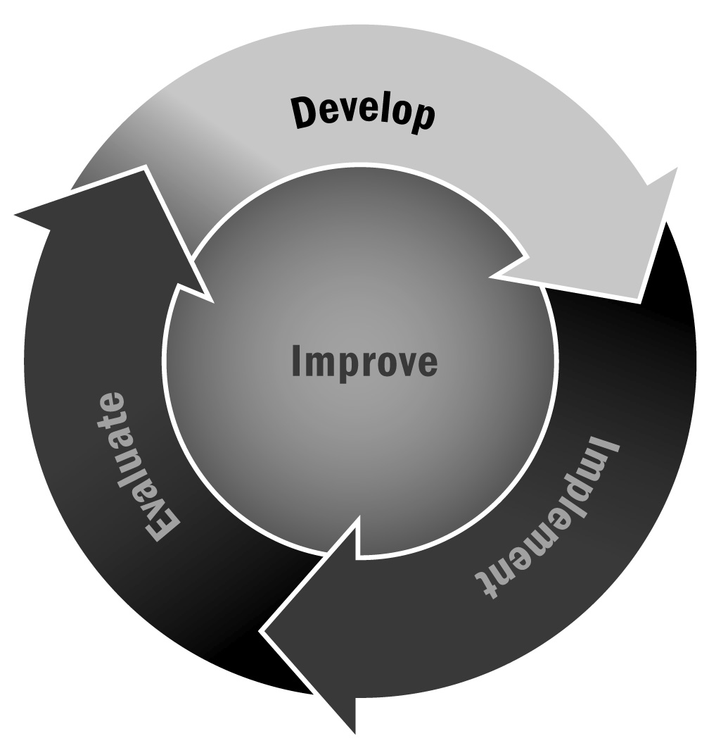
Candidate Expertise Questionnaire
In Chapter 1, you learned that your staff is central to the success of your afterschool and expanded learning program. For that reason, it is critical to recruit, hire, and retain staff members who are passionate about working with young people, creative and thoughtful, and committed to their work.
Directions: Use the following questions to learn more about the candidates interested in applying for staff positions.

Candidate Expertise Questionnaire
Name (please print): |  |  |  |  | Date:
Position you are applying for:
Phone number:
Email address:
Why are you interested in this position?
What job experiences have you had that would help you in this position?
Describe your experience with youth development or working with youth.

What skills have you acquired in your present or previous positions that make you an ideal candidate?
What is your highest level of education? Please list the degrees you have earned and give the name of the institution from which each degree was earned and the field of study of each degree.
List any other education or training relevant to this position.
What days of the week and time of day are you available to work?

