40

Logic Model Planning Tool
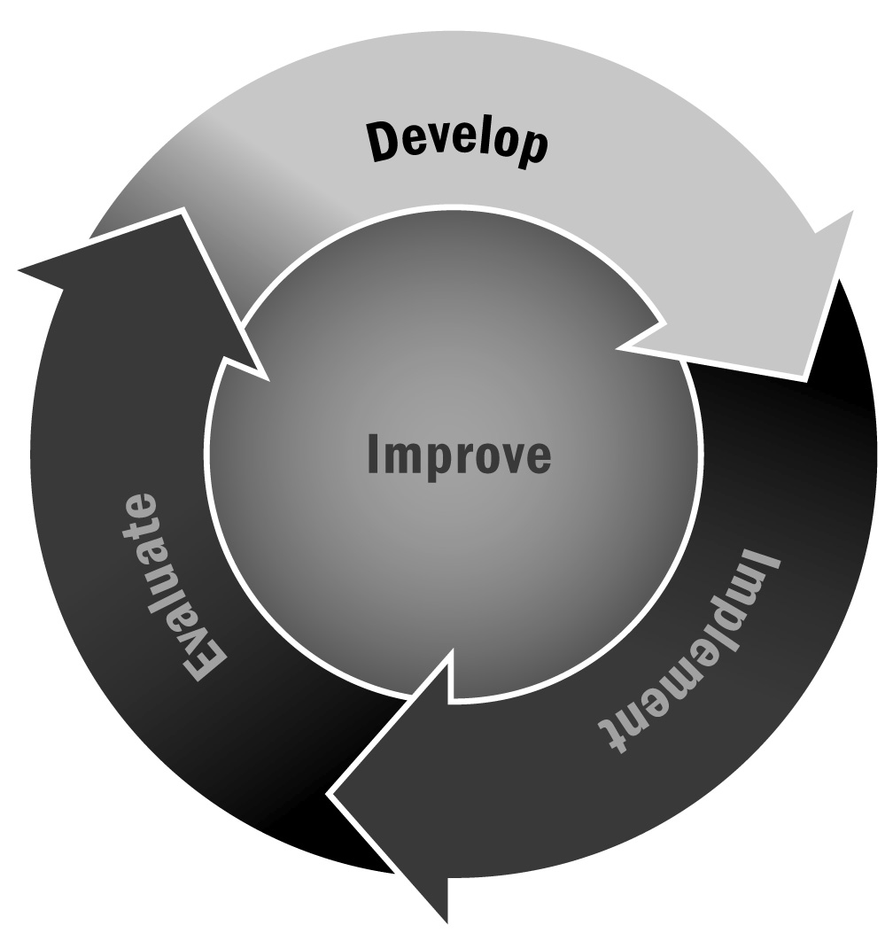
In Chapter 2, you learned about the importance of developing a logic model to accompany your goals, action steps, and theory of change. A logic model helps you articulate how you are going to achieve your vision and goals by implementing specific strategies.
Directions: As we mention in the text, there are many different ways to create a logic model and many good resources out there to help you along your way. One of the best and most comprehensive is the W.K. Kellogg Foundation Logic Model Development Guide, which can be downloaded from their website (http://www.wkkf.org). We offer one simplified approach below to get you started, but feel free to adjust, adapt, and seek out additional resources to support you as you develop a logic model that suits your program.
Step 1 – Bring Together Your Planning Group
A logic model should be developed in partnership with a strategic group—perhaps your advisory board or a group of representatives from your key stakeholder groups. It will likely take several meetings to develop your logic model. Ask people to commit to attending at least two or three meetings of at least two hours and to reviewing drafts between meetings. This can be a lengthy process, and it is important not to rush.
Step 2 – Determine the Scope of Your Logic Model
Together with your team, decide whether you are creating one logic model for your whole program or one for each major program goal. Based on this decision, talk about the level of detail you want to include.
Step 3 – Identify Your Components
As we stated in the text, a logic model shows the steps you need to take to make your program goals happen. It is your picture of how things will change and how you will achieve your intended outcomes. Most logic models contain five or six main components:
- Goals
- Objectives or action steps
- Inputs
- Activities
- Outputs (optional)
- Outcomes

Together with your planning team, use the table below to develop a list of things to include under each component. Don’t worry about order and format right now. Just make a list under each column.
Goals | Objectives or Action Steps | Inputs | Activities | Outputs | Outcomes
You developed your goals using Tool 37, so you shouldn’t need to create new ones. Fill in the goals from Tool 37 here. | Take these from your goal-setting process. Fill in the steps you noted in Tool 37. | These are what you need to carry out the action steps, including staff, supplies, and space.  Don’t forget to put your program theory here; that is your most important input. | These are the actual activities staff members will do with young people. | These are the direct results of a program—usually the size or scope of services. | This is where your SMART outcomes from Tool 38 should go. You may want to break these up into two columns—one for long- term outcomes (sometimes called impacts) and one for short-term or intermediate outcomes.
Example:  To provide a variety of arts classes after school | Partner with local arts organizations to facilitate on-site arts classes | - Local arts partners  - Staff  - Art supplies, messy space, and performance space | - Self-portraits  - Dance  - African drumming  - Final showcase | - 150 middle school youth served annually | Participants are able to talk about a variety of art media.  Participants demonstrate improved skill in their chosen medium.
Step 4 – Develop a Presentation
For simplicity, you can use the grid above to show the progression of your program from goals to outcomes. At a minimum, you will want to take your lists from the above grid and put them in some kind of logical order so that it is clear how one component flows into another. Most logic models, however, have some kind of graphic representation of this progression that uses some combination of shapes and arrows. This can be as simple as putting arrows between the columns above or as complicated as creating a flowchart with different levels and types of boxes and arrows. Together with your team, determine whether you want to turn the grid and lists above into a graphic that shows the relationship of one item to another and how you want to do that.
A couple of key tips to keep in mind:
- Remember your audience. Make sure that you aren’t using abbreviations or jargon and that others can understand what you have written.
- Keep it simple. A page crowded with boxes and words will overwhelm people. Do your best to simplify your language and create multiple logic models if you simply can’t cut back.
- Use uniform shapes, line thicknesses, and fonts to avoid visual clutter.
Step 5 – Gather Feedback
Share the draft logic model with staff, partners, community members, and families. Make sure that what you have created is clear and that it depicts what you want to depict about your program. Make adjustments based on feedback.
Step 6 – Revisit and Revise Often
A logic model is not intended to be created once and never used or revised. It should be a living document—one you update and revise regularly with your team as you make changes, adapt program elements, or tweak your program goals and intended outcomes. We suggest revisiting the logic model quarterly (or at least twice a year) to see whether it still makes sense.

