50

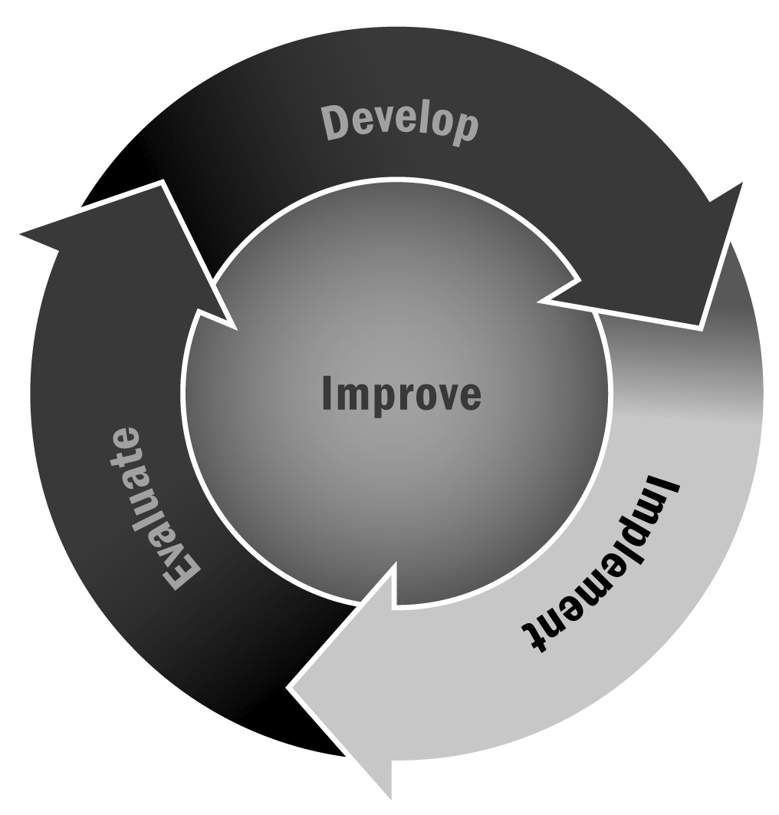
School Day Alignment Progression
In Chapter 3, you learned about the value of aligning your curriculum and activities with the information being covered during the school day. Allowing participants to build on school day learning through hands-on learning can reinforce school day lessons in a different way and provide a real-world application for participants.
Directions: The process of creating alignment with the school day takes time. The matrix below illustrates various areas where you may align with the school day and identifies the typical phases your program may go through as you move toward greater alignment. Examine this chart to determine your program's current level of alignment, and then use the blank chart that follows it to plan strategies for moving from one level to the next.

Characteristic | Beginning Alignment | Intermediate Alignment | Advanced Alignment
Curriculum | - School identifies activities cut from traditional school day because of budget issues (e.g., music, art) to be offered during program. | - Youth activities in the program are highlighted in school assemblies, or student work is hung in school building.  - School day teachers suggest various afterschool activities that extend classroom learning.  - Program activities are specifically designed to support core skills in math, literacy, and other skills identified by teachers. | - Activities are planned to coordinate with the school day curriculum.  - Students can submit work done in program for extra credit in class.  - Students can receive core academic credit for completion and documentation of high-quality program learning opportunities.
Recruitment of Young People | - Promotional materials for the program are distributed in classrooms. | - Program promotes itself in school day assemblies or recruitment fairs.  - Teachers actively encourage students to register. | - School day teachers recruit and refer students for the program.  - The school staff and program staff review data together to identify students in need of services.
Tutoring Program and Homework Help | - School day teachers work as tutors in the program.  - The district shares its standards and curriculum goals with the program.  - Time and resources are provided for young people to complete their homework. | - School day teachers send assignments to the program staff.  - School day teachers provide activities for program staff members and/or tutors to use to reinforce and enrich classroom activities.  - Program staff communicates with school day teachers about difficulties that students are having with homework. Teachers and program staff members /tutors develop two-way communication about homework. | - School day teachers and program tutors meet regularly to review student progress.
Recreational Activities | - Program recreational activities are coordinated with the school’s existing recreational offerings. | - School day staff informs program staff about schedule, and program staff plans activities to support and reinforce basic skills. | - Program and school staffs work together to plan recreational activities that support self-esteem, problem solving, character education, and other skills, in addition to physical development.
Internal Communication and Feedback | - Program activities are highlighted in school newsletters and other communication vehicles.  - Program offerings are displayed on school bulletin boards.  - Presentations about the program are made at school staff meetings. | - Program staff members participate in in-service trainings.  - The program’s site-level leadership regularly checks in with the school day staff about the program. | - There are joint staff meetings for program and school day staff members.  - Program staff members plan and present in-services for school day staff members.  - Joint planning of activities is ongoing.
Family Involvement | - Program staff members independently inform families about the program.  - Some family members may offer their help in the afterschool hours. | - School day staff members share information about afterschool activities with family members.  - School day staff members work with family members to recruit youth for the program.  - The program offers opportunities for families to learn about school activities and expectations. | - Afterschool and expanded learning staff members attend and participate in conferences/IEP meetings.  - School and program staff members share information about family needs in order to better support students.
Logistics | - The program is limited to one or two areas of the school—usually the gym or library media center.  - The program is coordinated with custodial and security staff. | - The program has access to several areas of the school, including classroom space.  - Space is designated for a program staff office.  - The program is responsible for its own transportation. | - Staff members from the program and school day plan for use of school building together.  - No space in the school is off-limits for the program.  - Transportation is considered as an area for cooperation.

Directions: After reviewing the matrix on the previous pages, use the table below to identify where you currently fit on the continuum (beginning, intermediate, advanced), the specific things your program is doing in each area, and steps you can take to move your program to the next level. It might be a good idea to complete this tool in partnership with school staff members as a way to discuss alignment and next steps. If you are in the very early stages of collaboration, complete the form without school input at first and bring them on board slowly. Your advisory board and other key stakeholders may also be important contributors to this conversation.

Characteristic | Current Level | What Your Program Is Doing | Steps for Enhancing Alignment
Curriculum
Recruitment of Young People
Tutoring Program and Homework Help
Recreational Activities
Internal Communication and Feedback
Family Involvement
Logistics

