58

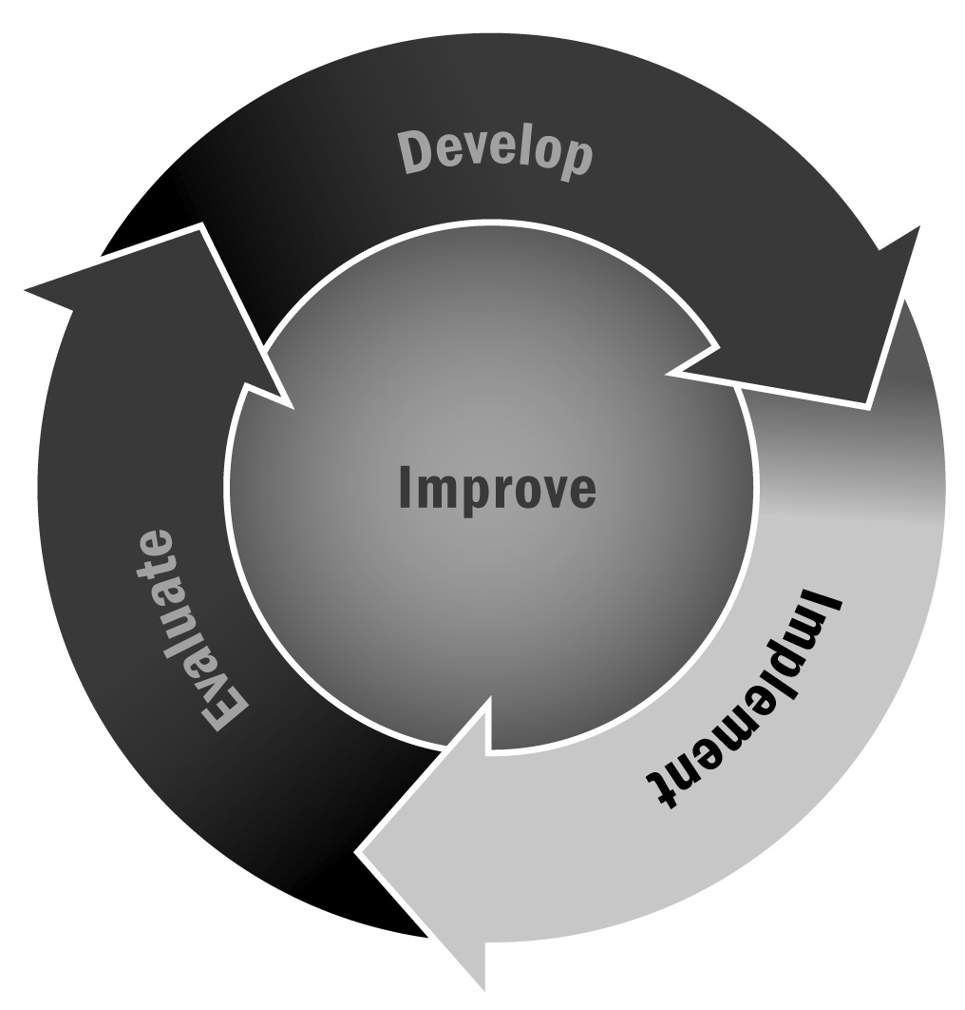
Identifying Potential Partnerships
In Chapter 3, you learned that not only are partnerships important, but selecting individuals or organizations to complement your mission is also crucial. Collaborations should encourage partners to contribute the resources they have to the broader collective. Several organizations and individuals (including your program) working together can create a whole that is greater than the sum
of its parts.
Directions: Review the tips below and then complete the worksheet on the following page to begin identifying partners and strategies for reaching out to them.

Tips for Identifying and Reaching Out to Potential Partners
- Revisit the work you have already done. By now, you have likely already captured a great deal of information about potential partners. Look back at your market analysis (Tool 15), your asset mapping process (Tool 34), and your needs assessment (Tool 35). In those tools, you identified a number of potential organizations for partnerships. List them in the appropriate categories below.
- Ask for what you need. Once community organizations have been identified, decide which ones offer the most potential to help with your program. Then reach out to the organization to discuss the possible collaboration you have in mind. Don’t be afraid to ask the organization for what you need—ask to set up a museum visit, for instance, or tell a local business you’d like a two-hour meeting with 20 youth and a top executive—and set an agenda. Start slowly and build. Consider opening your request list with items that can be delivered free of charge.
- Let your partners know why they could be so valuable, and explain how their participation benefits them. (For example, youth may return as future employees to a business; museums will build future members from the local community.)
- Consider a variety of partnership roles. Partners can lend support to a fundraising idea; mentor young people; offer expertise; or provide materials, services, or facilities to the program.
- Nurture your partners. Follow up after activities. Make sure youth send thank-you notes after events in which partners have participated. If a partnership is not working, end it gracefully. If a partnership is working, find ways to publicize its success—call your local newspaper or news blog, or invite them to an event.
- Bring partners together. Consider a year-end event at which partners can be honored for their participation. Ensure that youth participate and, ideally, that they plan the event.
- Make sure your partners represent your community. Make sure to include partnerships with people and organizations that represent the diversity of your community.

Name of Partner | Type of Partnership | Notes/Next Steps
Major businesses or industries in our community
Major civic and professional organizations
Colleges and universities
Public services (e.g., libraries, parks)
Religious groups
Artistic organizations
Other afterschool and expanded learning programs
Organizations that provide services for senior citizens
Media (newspapers, radio, TV stations that reach out to our community)

