70

Structuring Activities for Skill-Building
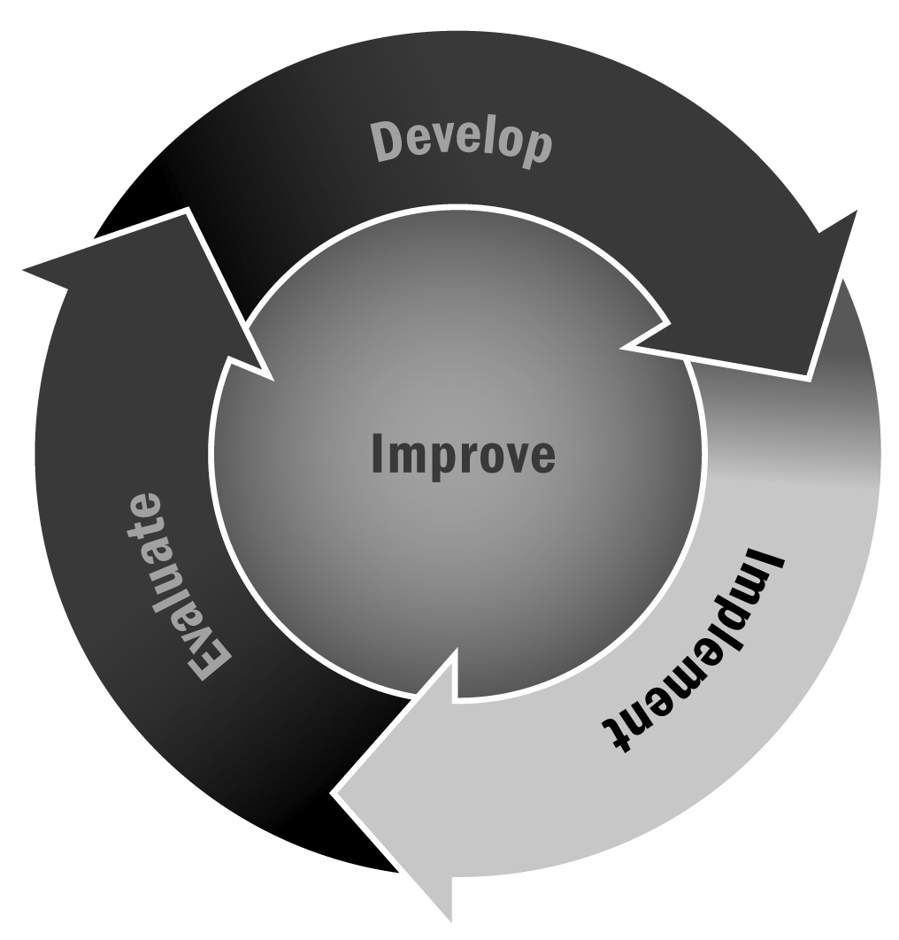
In Chapter 4, you learned that a critical component of youth development involves structuring activities so that youth are building and reinforcing new skills. Durlak, Weissberg, Dymnicki, Taylor, and Schellinger (2011) have identified four common elements in afterschool and expanded learning programs that are most effective in developing skills. These elements or characteristics, dubbed the SAFE features, are:
S = Activities are sequenced
A = Learning is active
F = Activities are focused on developing personal and social skills
E = Activities explicitly target specific skills and outcomes
Directions: Use the worksheet below to develop or review program activity plans to ensure that they are SAFE. An example is provided below, followed by a template for your use.

Skill-Building Activity Worksheet – Example
Anger Management: Just Breathe
Description: As part of working with youth to self-regulate individual and collective behavior, this activity will be used to introduce a culture of calm and weave it into the program.
What skills will you develop by conducting this activity? | Youth will learn how to calm down when they are angry to reduce anxiety, stress, and conflicts. They will learn self-regulation strategies such as deep breathing, counting to 10, and self-talk. Youth will also learn to identify emotions and their causes.
What ages are appropriate for this activity? | All ages; can be modified as necessary for younger or older youth
How long will it take to complete this activity? | Introduction: 10 minutes  Discussion: 10 minutes  Planning: 10 minutes
What materials are required for this activity? | Bell or chime  Tranquil music  Space to role-play
Have the young people in your program had experience with this topic before? (This will help you know how best to conduct the activity!) | Many youth (but not all) attended a three-week anger management course by ABC Community Services during school time earlier in the year.
SAFE Principles
Is the activity Sequenced?  Is there a step-by-step approach for teaching the skill? Outline the process. | First, youth will discuss different situations that might make them angry or sad and the different reactions they might have to those feelings. Next, youth will engage in small group discussion about the cause and effect of different responses to anger and other negative emotions.  Youth will then be introduced to different regulation strategies. They will begin with learning a deep breathing technique. In a large group everyone practices the breathing technique. Youth reflect or write down their experience. They will also discuss times when deep breathing is necessary, and they will share any tricks they use to calm down in their lives (and will record the results). Next they will learn a counting strategy, followed by self-talk strategies, and then engage in reflection and discussion.  Next, youth will engage in role-play scenarios that could potentially evoke a negative response in the real world. Youth will role-play the scenario and practice using one of the regulation techniques they have just learned. Staff members will observe and provide feedback to all youth. Youth will discuss how it felt to engage with those strategies.  Finally, youth and staff members will brainstorm ways to incorporate the various techniques into the program (e.g., every time the bell rings, stop and take a deep breath).
Is the activity Active?  What opportunities will youth have to interact with and practice new skills? Describe those opportunities. | Youth learn an individual skill and come together to share feelings and coping strategies. All youth will engage in the practice of deep breathing, counting to 10, and self-talk. Youth will role-play situations in small groups where these strategies would be needed and discuss what it felt like to engage in self-regulation.
Is the activity Focused?  Have you allotted specific time and attention for skill development? Describe when and how you will devote time to skill development. | This activity will take 30 minutes, and time has been allotted for this activity during the weekly program schedule.
Is the activity Explicit?  Do youth know which skills they will be developing as a result of the activity? Identify the specific skills and describe a plan for sharing with youth. | Social and emotional competencies developed through this activity include self-management, emotion regulation, emotion identification, and understanding cause and effect.  The instructor will first identify the goals of the activity and will then describe the skills that youth will work to develop. Youth will engage in small group discussion about the skills and goals of the activity.
Integrating Skills Into Other Activities
Youth need opportunities to connect newly developed skills to other areas and real-world experiences.  Highlight other areas of programming where these new skills can be embedded and further developed. | This activity will result in strategies to reinforce self-regulation techniques throughout programming. Use these strategies when youth are feeling stress, if a conflict arises, or after playing an energizing game in the gym.  This activity can be tied to science lessons on anatomy and bodily responses (e.g., how the heart works, why deep breathing calms us down).  Youth can read about different figures in history who have practiced self-restraint and peace.

Skill-Building Activity Worksheet – Template
[Name of Activity Here]
Description
What skills will you develop by conducting this activity?
What ages are appropriate for this activity?
How long will it take to complete this activity?
What materials are required for this activity?
Have the young people in your program had experience with this topic before? (This will help you know how best to conduct the activity!)

[Name of Activity Here]
SAFE Principles
Is the activity Sequenced?
Is there a step-by-step approach for teaching the skill? Outline the process.
Is the activity Active?
What opportunities will youth have to interact with and practice new skills? Describe those opportunities.
Is the activity Focused?
Have you allotted specific time and attention for skill development? Describe when and how you will devote time to skill development.
Is the activity Explicit?
Do youth know which skills they will be developing as a result of the activity? Identify the specific skills and describe a plan for sharing with youth.
Integrating Skills Into Other Activities
Youth need opportunities to connect newly developed skills to other areas and real-world experiences.
Highlight other areas of programming where these new skills can be embedded and further developed.

