71

Sample Activity Planner
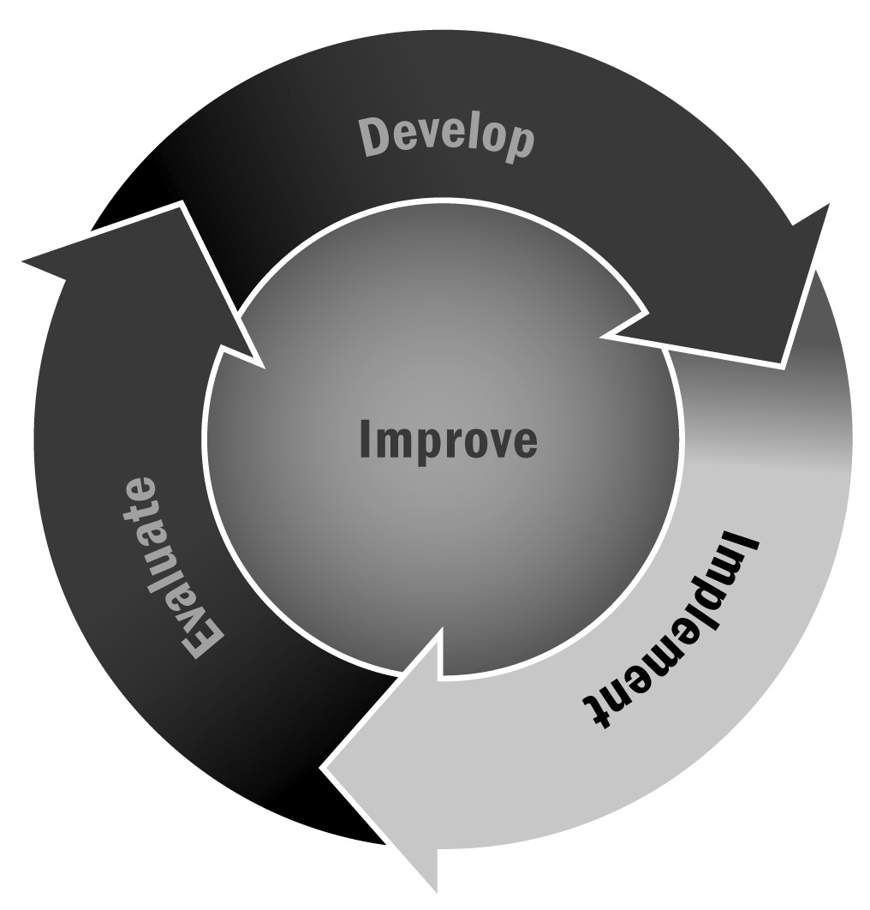
In Chapters 2 and 4, you learned that making and having a plan for program activities is key not only to smooth implementation but also to integration of youth development principles and intentionally supporting participants’ engagement, learning, and development.
Directions: This sample activity planner integrates all of the program delivery practices described in Chapter 4. Staff members can use this planner or modify as needed. We recommend that staff members complete the activity planner at least once for each activity. After trying the activity out, use the reflection questions to adapt and revise.
Logistics
- Activity name:
- Staff member(s) and youth leader(s) facilitating the activity:
- Duration of activity (number of sessions/weeks/days/hours):
- Supplies/materials/space required:
- Ages/grades of participants:
- Number of participants:
Content Area (check all that apply, but circle the primary content area)
❒ | Creative arts | ❒ | Health and wellness |  | ❒ | STEM | ❒ | Personal and social skills
❒ | Sports and recreation | ❒ | Service learning |  | ❒ | Tutoring | ❒ | Homework help
❒ | Literacy | ❒ | Other, please specify:

Youth Development Principles
Briefly describe how you will structure the activity to intentionally incorporate core youth development principles.
- Warm and Welcoming Environment (e.g., icebreakers, welcomes, and introduction to both the activity and the participants):
- Supportive Relationships and Opportunities to Belong (e.g., identity development and structuring of groups):
- Support Positive Behaviors:
- Youth Choice (e.g., choices within and across activities):
- Authentic Decision-Making:
- Youth Leadership:
- Time for Reflection:

Description
Describe your activity in detail. Be sure to include details about what participants will be doing, what the staff member will be doing, and how you will break up your time. Be sure to make this clear and specific enough that another person could read it and be able to implement that activity:
Activity Structure to Support Skill Development
Describe how the activity will meet the SAFE (Sequenced, Active, Focused, and Explicit) criteria:
Sequenced:
Active:
Focused:
Explicit:
Outcomes/Connections
List the intended outcomes of the activity (what knowledge you hope youth will learn or what skills you hope they will develop):
Describe if/how the activity intentionally supports the participants’ academic learning:
Is this activity linked to other activities? Which ones and how?
Reflection
How did the activity go?
What did you learn?
What would you do in the future?
Would you share this activity with other afterschool and expanded learning programs?

