77

Assessment of Recreational Needs, Resources, and Space
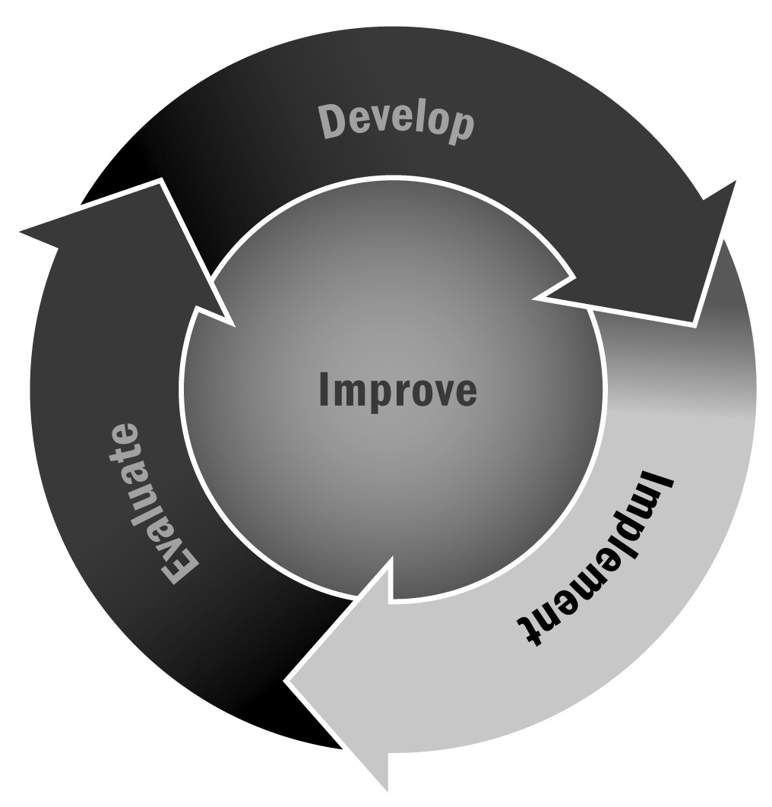
In Chapter 4, you learned that it is important to take your program’s available space and resources into account when developing your recreational activities.
Directions: Use this tool to compare your recreational needs with your available resources and space. Then consider ways to address your needs.

Recreational Activity | Space/Resources Needed | Space/Resources Available | Ideas to Address Remaining Needs
Example:  Youth in the program want to start a marching corps. | Space: Large space, outdoors during fall and spring, but indoors in the winter  Resources: Music and batons | Space: Program has outdoor space  Resources: iPod and the theater speakers for music | The local high school may allow us to use the gym on their off days. We will work with youth to organize a fundraiser to buy batons.
 | Space:  Resources: | Space:  Resources:
 | Space:  Resources: | Space:  Resources:
 | Space:  Resources: | Space:  Resources:

