89

Tips for Conducting Program Observations
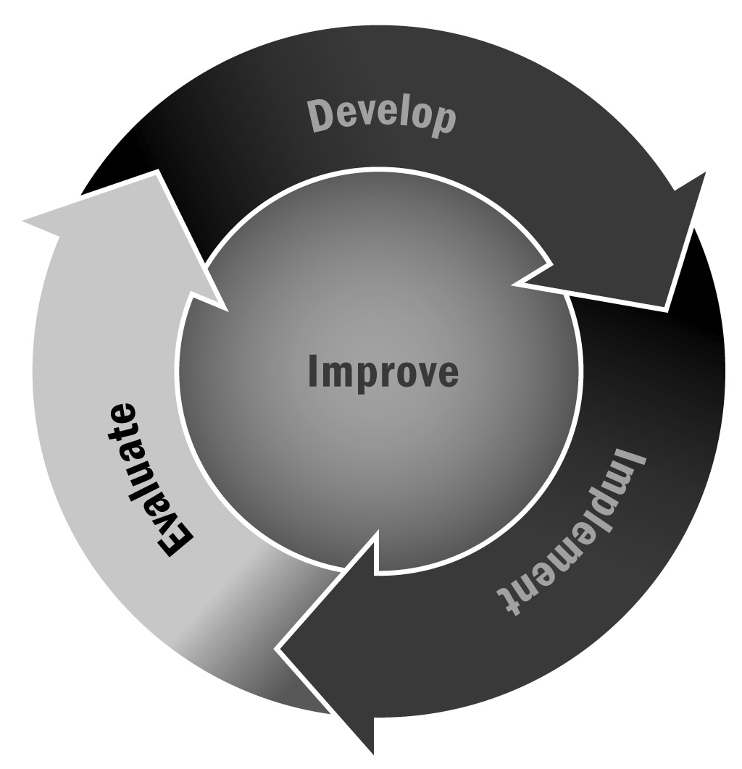
In Chapter 5, you learned that no matter how well you plan your activities, your evaluation questions, and your evaluation plan, it will all be for naught if you don’t have a useful way to collect the data you will need to answer your evaluation questions. One way to collect data is through program observations. Program observation data are also incredibly useful in making immediate program improvements.
Directions: Use the following tips when conducting program observations as part of your data collection efforts. Please note that there are many observational assessments available for programs to use. Refer to Tool 85: Program Observation Tools for a list of tools that are the most common in the field, are research-based, are appropriate for a variety of program settings, and focus on the interactions between people in the program.
- Review the observation protocol in advance of conducting the observations so that you are familiar with what you need to be observing.
- Bring a hard copy of the observation protocol.
- Bring a notepad and pen to take notes in case you have computer problems.
- Turn off cell phones.
- Be prepared to explain why you are conducting the observation.
- Select a location in the room that is out of the way so you do not disrupt the activity.
- Stay on schedule and allow yourself enough transition time between observing different activities.
- Plan to observe an activity for at least 50 minutes in order to collect enough information for the observation.
- Keep an open mind. You are observing behaviors—not judging them in terms of good or bad, or right or wrong.
- Take detailed notes, including recording the date, time, and place; and review and clean your notes as soon as possible after completing the observation.
- It is helpful to have a reflection form to complete after an observation that captures overall observations and specific details about the behaviors you were observing.

