91

Data Discussions
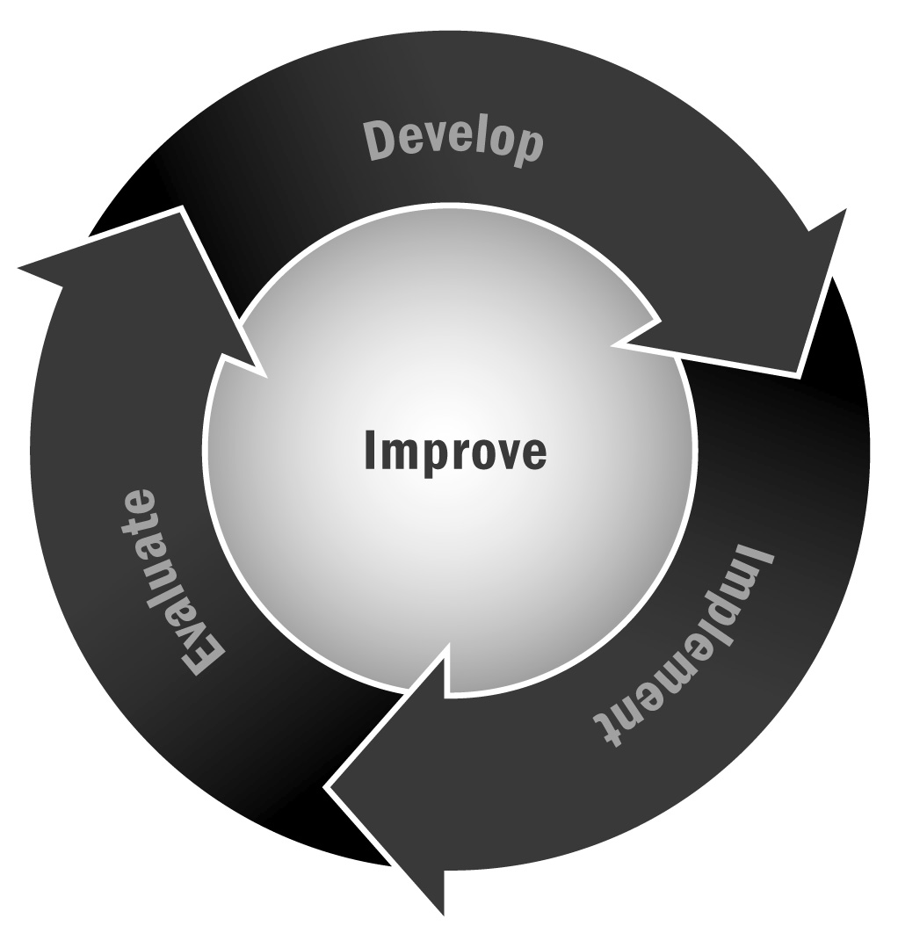
In Chapter 6, you learned that it is important to review data from your program on a regular basis and use them to make changes and improvements. Incorporating data discussions into your staff meetings and other regular conversations can be an important part of establishing a culture of data collection and use.
Directions: This tool describes some common types of data and tips for using and discussing them on a regular basis with your staff and advisory teams.

Data Type: Youth Participation Data
Ways to use data for planning:
- Look at the average daily attendance for each activity or program—look for patterns. Do certain types of programs have high attendance while others have low attendance? Are there certain days of the week that have higher attendance than others? Do certain instructors or staff members have better attendance than others? Are there certain times of year (e.g., right before and after vacations) where attendance appears to be low?
- Think about programmatic changes you can make to boost attendance. For example, if attendance is low on Fridays, consider placing highly popular programs on that day, or create a “Fun Fridays” program with alternative, engaging programs like movies, field trips, or themes. If you notice some types of programs have low attendance and others high, consider combining activities so that youth receive both during a given program period.
- Analyze and discuss these data at regular intervals—a few weeks after the start of programming to make course corrections and toward the end of the session to look at trends and prepare for the next session.

Data Type: Youth Program Satisfaction Survey Data
Ways to use data for planning:
- If you survey youth on a regular basis, make sure you use the data. Youth need to see that it was worth their time to fill out the survey so they will take it seriously in the future.
- First you’ll need to have someone tally the survey data. Put the results in an easy-to-read presentation to share with the staff at a staff meeting.
- Discuss what you found and how/if you can make changes—for example, if youth report high levels of satisfaction with the adults in the program but are less positive about their peers, you might need to promote team building and peer-to-peer interaction in your next session. If youth report frustration with the behavior of some youth during program time, you may need to spend more time on your group guidelines and program rules.

- Some things you won’t be able to change—say, the schedule of the program—but you should still discuss how to address them. Talk to youth about the change they requested and why it isn’t feasible to make a change right now (e.g., “We don’t have enough funding to make the program an hour longer, but we hear that you want that and we will work to identify funding for next year”).
- Use youth interest to drive program selection. Ask youth what activities they would like to see and tally the results. If certain activities show up a lot, consider adding them or including them as special requests in your request for proposals for outside providers or vendors.

Data Type: Program Observation Data (e.g., from a quality assessment tool)
Ways to use data for planning:
- After a series of program observations, when you have enough data for them to be anonymous and aggregated 9 (i.e., combined) bring the staff together to discuss. It is important that there be enough data (at least 5–10 observations) so that no one program or instructor can be identified.
- Talk about strengths and weaknesses for the program as a whole—what do you notice about the data? Where is the program as a whole doing the best? Are there one or two areas that all activities are struggling with? How can you, as a team, address the areas that need growth?
- With a smaller management team, you might use the data to discuss professional development you want to offer, key characteristics you want to add to job descriptions for new staff members, mentoring opportunities for some staff members, and other staffing changes that might address some of the problem areas while celebrating the success of strengths.

Data Type: School-Related Youth Data
Ways to use data for planning:
- If you are able to get records from the school, you may have access to student-level data on things like attendance, discipline incidents, grades, and test scores. These data, although challenging to work with, can be very useful for your program planning.
- If possible, hire someone to crunch the data for you. At a minimum, use the data to identify the highest risk/need youth in your program. You may define those as the lowest performing, those with the most discipline incidents, those with the most absences, or some combination of those.
- Next, discuss ways to improve the program to better serve youth in need of additional support. What can you do to improve their attendance? How might you connect them to better tutoring supports—perhaps assigning certain youth a one-on-one tutor to help boost their grades or assist with homework completion? Is there a young person with behavioral problems who would benefit from participating in a mentoring activity? Work with your staff members who know them best to identify solutions.

